Press release
Czech audiovisual industry faces dramatic drop due to suspended incentives,
but reports record turnover for 2021
According to representatives of the APA (Audiovisual Producers´ Association),
the Czech audiovisual industry finds itself on the edge of a precipice. In future years,
the estimated decline may reach the 2010 level, when the audiovisual industry's turnover was CZK 3.58 billion. At the same time, the past year 2021 will go down in history as a record year, with the turnover of the Czech production companies associated under the APA reaching incredible CZK 12 billion and surpassing even the best pre-pandemic turnover
of CZK 9.46 billion in 2019. According to the association, the reasons for the projected decline are not related to the quality of domestic audiovisual production, but are systemic,
due to the suspension of registration for film incentives in the Czech Republic announced
on 3 January 2022.
After the success of 2021 comes the crisis
The suspension of incentives will lead to a sharp outflow of foreign projects already
in the second half of 2022 and especially between 2023 and 2024. The whole of Europe strives to attract global streaming platforms which have been investing heavily in their own production since 2018. However, film giants are moving their projects from the Czech Republic to neighbouring countries such as Poland, Hungary and the Baltic States. Even Slovakia becomes a competitor to the Czech Republic. The biggest international players are already leaving, including the production of Devil in the White City, produced
by Martin Scorsese and Leonardo DiCaprio and starring Keanu Reaves. Among other projects we are losing are Patriot 3 for Amazon Studios, Sisterhood of Dune for HBO Max,
a Hunger Games prequel starring Jennifer Lawrence, the action film Shadow Force
with Kerry Washington, and Londongrad with Benedict Cumberbatch for HBO.
"The current incentive system is in crisis; it ran out of gas in recent months and has come
to a standstill; it needs to be reformed. Thanks to the quality of services and incentives,
the Czech Republic has managed to attract numerous mostly long–term series projects
from international platforms such as Netflix, Amazon, or Apple in the last few years. These platforms use a huge volume of services in the Czech Republic, spend about CZK 9 billion
a year and employ 20,000 people, mostly in non-film professions and services. Incentives pay off for the Czech Republic, no doubt about that. The funds invested in them are returned tenfold. The situation is dramatic, we are currently holding talks with the Ministry of Culture and the Ministry of Finance to make it possible for large foreign projects and smaller European and domestic productions to continue filming in the Czech Republic," said APA President Vratislav Šlajer.
Film and television producers are expecting tough times too. The suspension of incentives does not only mean an outflow of foreign projects, but also a new threat that domestic film and television projects will move to neighbouring countries too. The Czech Republic´s incentive was 20 % of eligible costs, while Slovakia offers 33 %, and Poland 30 %.
For Czech producers and TV stations it is not difficult to move production to neighbouring countries, which is, in many cases, already happening.
The Czech Film Fund faces new problems too, as the contribution of CZK 760 million from the National Restoration Plan, the fund counted with, was suspended. Together
with the drop in cinema revenues, this is a major slump in the planned income
of an audiovisual fund. "The absence of audiovisual industry in the National Recovery Plan is shocking. Originally, it was included, but the Ministry of Industry and Trade under the former government moved the amount from the European to the so-called Czech part of the budget, where there are currently no funds, leaving audiovisual industry empty handed. Minister
of Culture, Martin Baxa, must strongly request the funding. The funds in the National Recovery Plan are to be increased, so there is still a hope to get the money," Šlajer explains.
According to APA, the Czech Republic has lagged behind other European countries also in advocacy of the national interest to keep domestic content on international platforms. While Denmark, for example, reports 6 % of revenues from Danish VOD service users to support original film and television production, the Czech government leaves global streaming platforms without any commitments, even though the EU's Audiovisual Media Services Directive allows for determination of minimum investments in production,
or acquisition of local content. "In addition to Netflix, people can subscribe to HBO Max, Apple TV+ or Amazon Prime, and newly also Disney+. Great news for movie fans, worse
for distributors and producers. Streaming has a hard impact on cinema attendance, which remains the main source of revenue for Czech films. Other European countries are preparing measures to support domestic audiovisual production in this new situation, while in Czech Republic, this process takes place under time pressure, due to the threat of fines, and it has not yet been possible to enforce in Czech legislation a system of direct investment – meaning that a part of the country revenues could be invested in domestic audiovisual production," explains Vratislav Šlajer from APA.
The recent development in Czech Television, which – based on rising inflation and a stagnant license fee – announced a drop in production, doesn´t bring any good prospect
for independent producers either. The cuts will affect Czech TV´s own production as well
as its domestic co-production projects.
"We are facing a slump and a protracted crisis. However, this collapse has nothing to do
with the potential of Czech audiovisual industry, as it is solely a consequence of unresolved systemic problems. European countries are racing to increase investment in the industry, to strengthen grant support, launch new incentive programmes. The reason for them to do so is simple: Audiovisual industry is a high–growth, value–added sector, bringing new investment and jobs to many people in times of crisis, as proven by the results of 2021, when – despite the covid crisis – the Czech audiovisual industry remained one of the most stable and growing cultural sectors. Instead of continuing to support this growth and help the Czech economy compensate for the looming economic crisis, it´s left to decline," adds Šlajer.
ACHIEVEMENTS OF 2021
Last year, audiovisual industry not only returned to its pre-Covid figures, but even surpassed the results of 2019. International projects turnover in 2021 was CZK 8.73 billion,
i.e. 70 % of the total audiovisual industry turnover. Advertising production turnover reached CZK 1.86 billion, while Czech film brought CZK 1.26 billion in 2021.

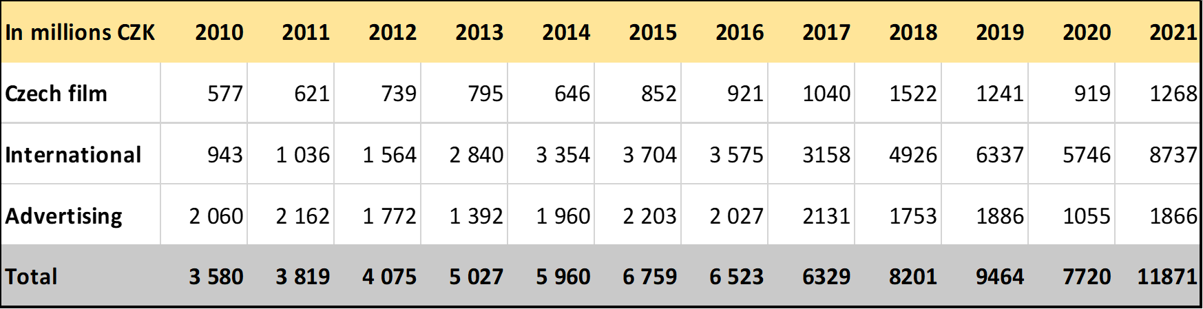
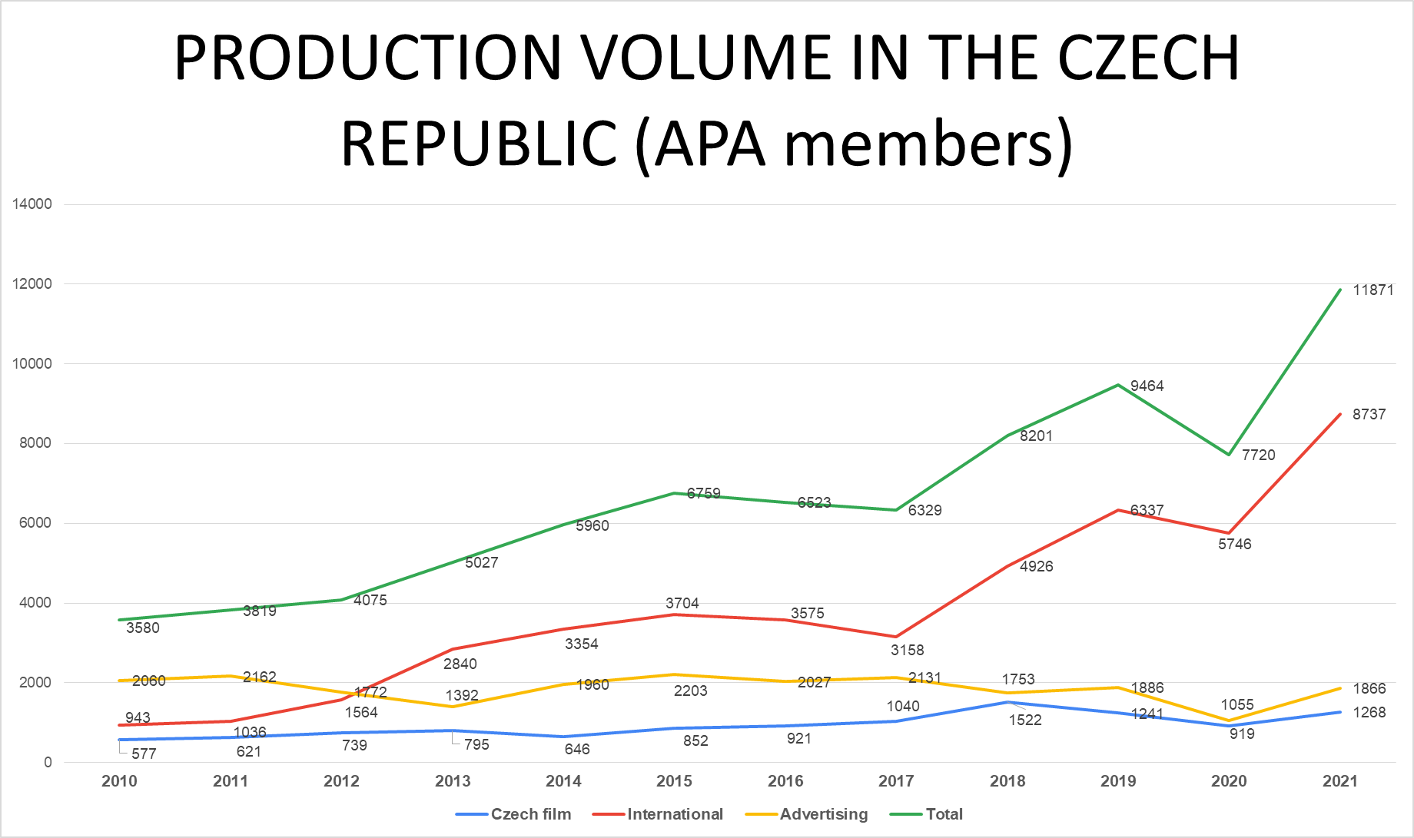

Until the outburst of the pandemic, the Czech audiovisual market showed a growing trend. During 2020, which was the first year of the pandemic, it saw a decline, however, last year, domestic filmmakers managed to survive, despite the pandemic. The Czech Republic was
the first country in Europe to introduce measures allowing safe filming, and it has rightfully become a magnet for global filmmakers. The projects which were registered
in the production incentive system at the end of 2021 are currently still being filmed here. One of the films attracted to the Czech Republic by the incentive system, was the US action thriller
The Gray Man starring Chris Evans and Ryan Gosling. This film got exceptional attention
of Czechs and foreign tourists, not only because of the movie megastars, but also thanks to
the explosions, shootings and car chases taking place right in the centre of Prague. In just
18 days of filming here, the filmmakers had spent over 750 million crowns.
Netflix spent over CZK 2.5 billion in 75 shooting days on the sequel to one of its most successful and expensive films, Extraction 2 with Chris Hemsworth. The film locations included Ústí nad Labem South and Central Bohemia. Filming also continued on the epic
sci-fi series based on Robert Jordan's bestselling book The Wheel of Time starring Rosamund Pike, which has spent CZK 4.4 billion in the Czech Republic to date, and the fantasy series Carnival Row starring Orlando Bloom, with a total spend of CZK 3.9 billion for the first two seasons. Other projects being filmed here thanks to production incentives include
On the Western Front Quiet for German Netflix starring Daniel Brühl, the spy series Totems for France's Gaumont, Hasbro's animated series Magic: The Gathering, Chevalier for Disney, and the post-production of Guy Ritchie's new movie Operation Fortune, among many others. The second season of The Foundation, for Apple TV+, based on the books by Isaac Asimov, is also being produced here.
In 2021, after the 2020's decline caused by covid, advertising production returned to its turnover from 2019, thanks to numerous domestic advertising contracts, whose figures grew before the pandemic as well as during the last year. International productions are – according to representatives of the APA's advertising section – slowly returning to the Czech Republic too, although the increase in domestic prices is causing an outflow of smaller advertising companies, in particular eastwards, to countries such as Poland, Lithuania, Romania, Bulgaria and in 2020, also Ukraine. At the same time, clients from USA, Great Britain, France, or Germany are happy to return to the Czech Republic thanks to the quality of service, although nowadays they perceive the Czech Republic as quite an expensive place.
Last year, independent Czech companies focusing on film and television production reported a growing turnover of CZK 1.26 billion, which, after a 26 % drop caused
by the 2020 covid pandemic, was slightly above the 2019 level (CZK 1.24 billion). This is also due to the global trend of increased demand for audiovisual production from VOD service providers, streaming platforms, and TV companies.
According to statistics from the Film Distributors´ Union, the attendance of Czech cinemas as well as box office revenues grew last year compared to 2020. Due to the covid pandemic and cinemas closure from 1 January to 23 May 2021, the attendance could by no means compete with 2019, even so, it reached 7.142 million, which is, compared to 2020,
a year–on–year increase of almost 12 %.
Box office revenues in 2021 amounted to CZK 1.09 billion, which is a year–on–year increase of 20 %, while before the pandemic, the decrease in revenues and attendance was approximately 60 %. The results of Czech premieres in the past year should be viewed through the lens of the pandemic when individual films entered cinemas between various covid waves, and a part of the distribution offer were renewed premieres. The absolute winner of last year's attendance was the comedy Bet on Friendship which, with more than 600,000 viewers, has beaten even foreign films. The film, however, managed to have five times more screenings than its biggest competitors. The second position in the domestic ranking was occupied by the biopic Zátopek, with the attendance of 394,000. The documentary Karel about the popular Czech singer Karel Gott (392,000) reached a third place.
Czech feature, animated, and documentary films participated at numerous international film festivals in 2021. The year started with a great success at Berlinale, where Bad Luck Banging or Loony Porn, a co-production with Czech participation, won the Golden Bear
for Best Film. In Cannes, Vojtěch Jasný's restored classic When the Cat Comes resonated, while the Venice IFF presented four feature films with Czech participation – Leave No Traces, Miracle, 107 Mothers and Il Palazzo. At Tallinn Black Nights IFF, Occupation held its international premiere in the main competition. Czech animation celebrated great international successes in 2021. My Sunny Maad was selected for the main competition
at Annecy, receiving the Jury Prize, plus a Golden Globe nomination. Even Mice Belong
in Heaven was nominated for the European Film Awards. The animated shorts Dear Dad and Red Shoes, made at FAMU, scored at foreign festivals too. The FAMU documentary debut Brotherhood won the main prize at the Locarno IFF. The Karlovy Vary IFF, which included documentaries in its main competition last year for the first time, showed At Full Throttle and Every Single Minute, awarded the Special Jury Prize. Czech documentaries Anny
and A New Shift were also among the awarded films at international film festivals.
APA – Audiovisual Producers´ Association
Martina Chvojka Reková, martina.rekova@4press.cz, +420 731 573 993 Národní 28, Praha 1 www.asociaceproducentu.cz

More about film incentives
The Czech Film Fund has so far had at its disposal the budget of CZK 800 million
for production incentives; in recent years, based on increased demand, especially for large and long-term projects, the funds have been increased by another CZK 300 to 500 million during the course of each year. The Czech Republic offers an incentive of 20 %
of the so-called eligible costs, which is the lowest percentage of the production incentive
in the whole of Europe. All other European countries, aware of the great growth potential
of this creative industry sector offer a higher incentive, thus attracting filmmakers to their territory.
In the Czech Republic, the projects need to be registered before the filming starts
and incentives are only paid out after film crews have accounted for the money they spent
on Czech services and products. More than 80 projects, including co-production
and commissioned projects, have been realized in Czechia in the past year only thanks
to production incentives. While the Parliament is currently negotiating about the introduction of a cap of CZK 150 million per project, the APA believes that in the future it would be appropriate to approach incentives within two different corridors: separately for international projects and for smaller European co-production projects and domestic productions. Before the inevitable transformation of the Czech Film Fund into the Audiovisual Fund
and the amendment of the Audiovisual Act, APA representatives call for an increase in the existing and already depleted budget for film incentives. The Czech Republic is
an attractive destination for filmmakers from all over the world, with its quality film infrastructure and experienced professionals. However, the suspension of incentives makes it less competitive and less predictable for any business.

